**Assignment 1**

**OO Programming Fundamentals, 2014**

You are required to develop a student system for the Royal College of Surgeons course the “**BSc. in Nursing (Hons)**” that **repeatedly** presents the following menu to the user:

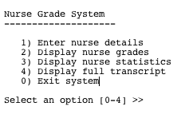

1. When option 1 is selected, the system asks the user to enter in a particular nurse’s information as per the screen shot below. You should add validation so that only grades between 0 and 100 (inclusive) are stored. Anytime the user enters an invalid grade, the system should print an error message and ask the user to re-enter a valid grade.

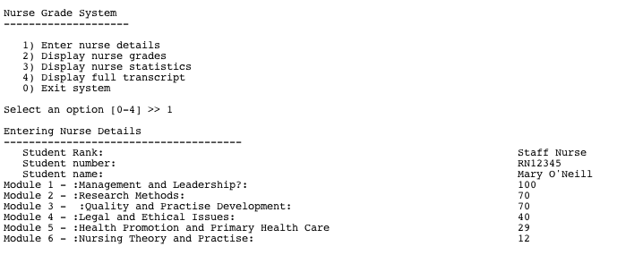

1. When option 2 is selected, the system displays the entered nurse’s data to the user as per the following screen shot. If the user attempts to select option 2 when no nurse data has been entered, the following error message should be printed to the screen:

**No nurse details entered: please enter the nurse details via option 1**

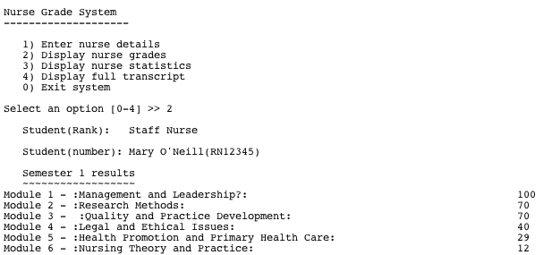

1. When option 3 is selected, the system displays statistics on the entered nurse data as per the following screen shot. If the user attempts to select option 3 when no nurse data has been entered, the following error message should be printed to the screen:

**No nurse details entered; please enter the nurse details via option 1**

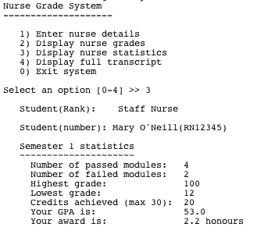

1. When option 4 is selected, the system displays: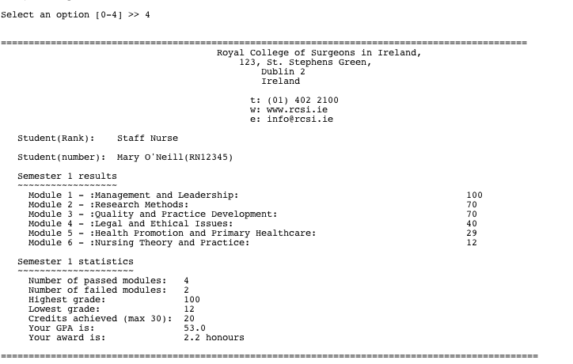
2. When option 0 is selected, the following message is displayed to the user and the system stops running.

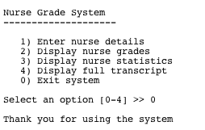

**Information on calculating the statistics:**

* + A passed module is any module that scored 40 or more.
  + A failed module is any module that scored less than 40.
  + The highest grade displays the highest score achieved over the six modules.
  + The lowest grade displays the lowest score achieved over the six modules.
  + The credits achieved is the number of passed modules multiplied by 5.
  + The GPA is the average of the six grades.
  + The award is based on the following rules:
    - A “Fail” is awarded when the GPA is less than 40.
    - A “Pass” is awarded when the GPA is between 40 and 49 inclusive.
    - A “2.2 honours” is awarded when the GPA is between 50 and 59 inclusive.
    - A “2.1 honours” is awarded when the GPA is between 60 and 69 inclusive.
    - A “1st class honours” is awarded when the GPA is 70 or above.

Important Points to consider when developing this system

1. Do not use methods, other than the main method.
2. Do not use arrays.
3. You should use a switch statement for controlling the menu options [0 – 4].
4. This is an individual project. Absolutely **NO** team efforts allowed.
5. Code **MUST** be commented.
6. Your program **MUST** run as stated in question specification.
7. Any sign of cheating/copying will result in a **ZERO GRADE** for all students regardless of who wrote the original code.
8. By uploading your assignment, you are electronically signing the WIT anti-plagiarism declaration. Please see the WIT website for more details on this policy.
9. You will be interviewed on your programs when they are submitted to determine authorship and understanding. These interviews will take place during your practical and tutorial classes. Make a copy of your assignment for interview purposes and remove **ALL** comments prior to interview. You will only be interviewed on un-commented code.
10. You will receive a grade for your interview. This is a multiplier for your assignment grade.
11. Please submit by the date posted in Moodle. You must submit the fully commented project via moodle (zip and upload, folder called YourName).
12. Late submissions will not be accepted (unless medical certificate is produced

**Guidelines for the “BSc. in Nursing” Project**

1. All class names should start with an upper case letter
2. All variable names should start with a lower case letter
3. Ensure you have chosen the correct data type (i.e. marks should be double not int)
4. When you need to carry out calculations ensure you do them at the correct time (usually after the values have been taken in)
5. Do not carry out calculations a second time if you have already calculated them. Just reuse the variables where the result is stored.
6. Ensure you layout your code in a readable manner (indentation etc).
7. Comment your code adequately. There should be a class level comment. Each method should be commented and any complex code within methods should be commented.
8. To maximise marks, stick to the specification given and code exactly what is asked.
9. Zip the directory containing your entire project; don’t just submit the .java file.